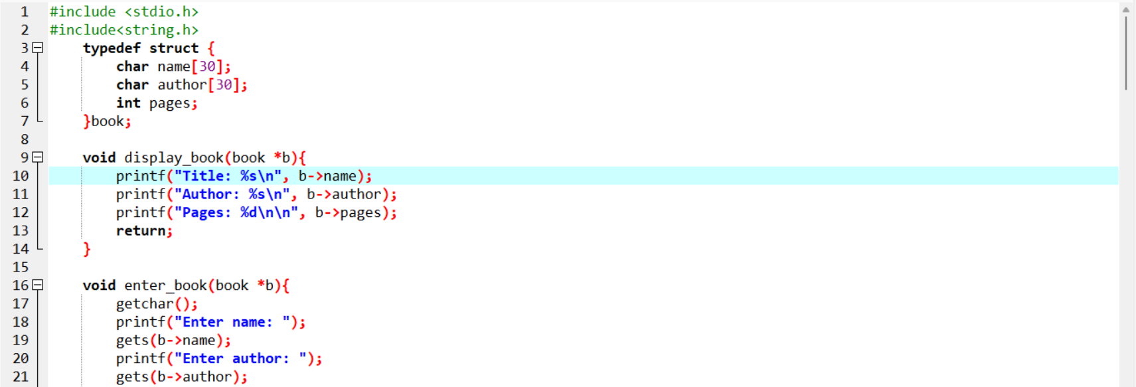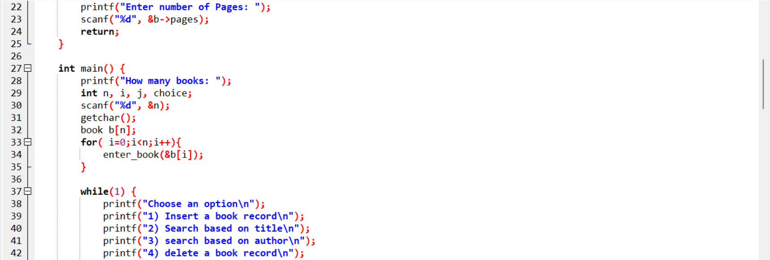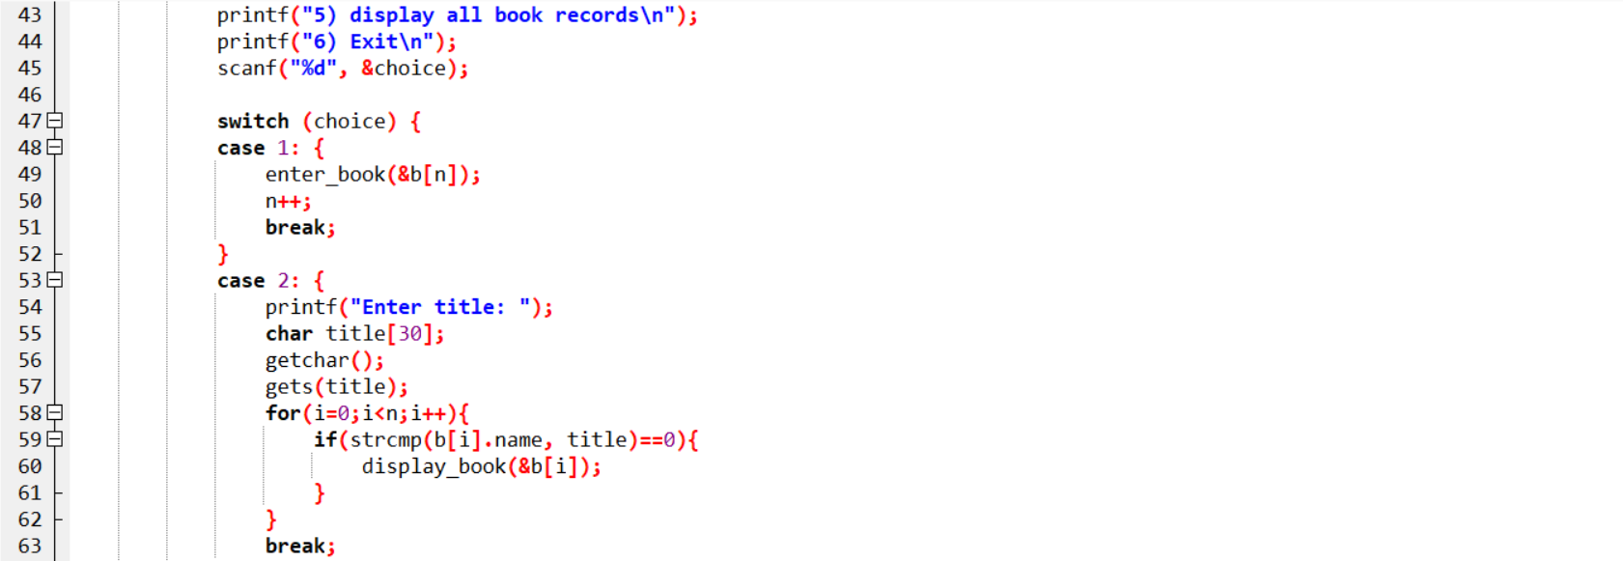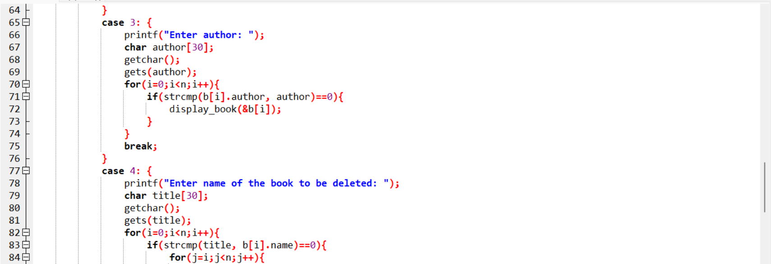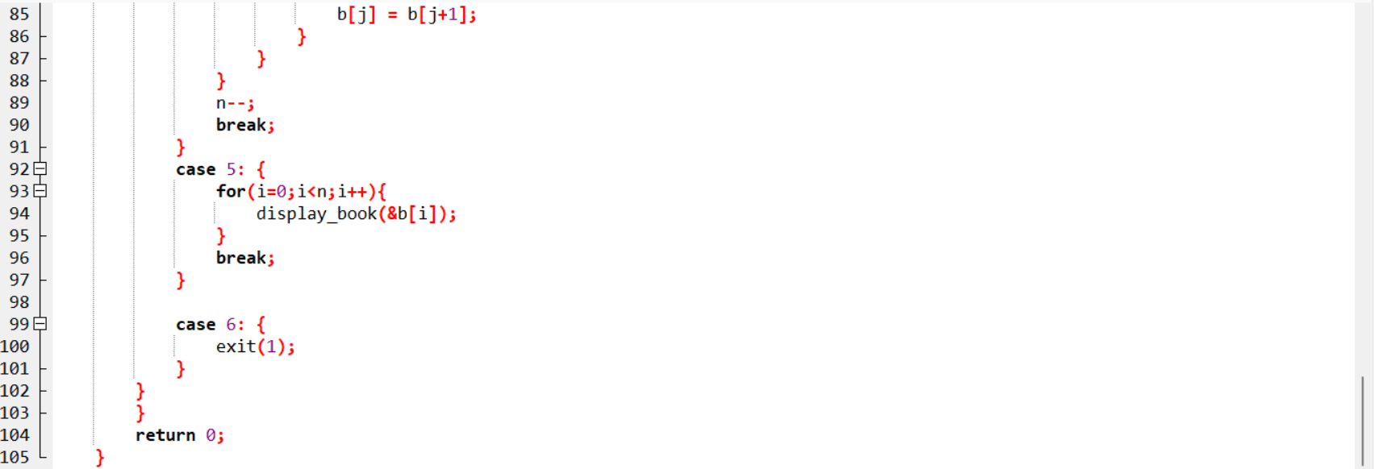

Output:

How many books: 1

Enter name: data strctures

Enter author: srivastava

Enter number of Pages: 500

Choose an option

1) Insert a book record

2) Search based on title

3) search based on author

4) delete a book record

5) display all book records

6) Exit

1

Enter name: computer organisations

Enter author: stallings

Enter number of Pages: 300

Choose an option

1) Insert a book record

2) Search based on title

3) search based on author

4) delete a book record

5) display all book records

6) Exit

5

Title: data strctures

Author: srivastava

Pages: 500

Title: computer organisations

Author: stallings

Pages: 300

Choose an option

1) Insert a book record

2) Search based on title

3) search based on author

4) delete a book record

5) display all book records

6) Exit

1

Enter name: cpp programming

Enter author: balaguruswamy

Enter number of Pages: 450

Choose an option

1) Insert a book record

2) Search based on title

3) search based on author

4) delete a book record

5) display all book records

6) Exit

3

Enter author: balaguruswamy

Title: cpp programming

Author: balaguruswamy

Pages: 450

Choose an option

1) Insert a book record

2) Search based on title

3) search based on author

4) delete a book record

5) display all book records

6) Exit

2

Enter title: data strutures

Title: data strcutres

Author: srivastava

Pages: 500

Choose an option

1) Insert a book record

2) Search based on title

3) search based on author

4) delete a book record

5) display all book records

6) Exit

4

Enter name of the book to be deleted: computer organisations

Choose an option

1) Insert a book record

2) Search based on title

3) search based on author

4) delete a book record

5) display all book records

6) Exit

5

Title: data strcutres

Author: srivastava

Pages: 500

Title: cpp programming

Author: balaguruswamy

Pages: 450